**1.6 CONCEPTUAL FRAMEWORK (ongoing)**

The following diagram describes the flow and process of Axion in different user-students state, the diagram is presented below.

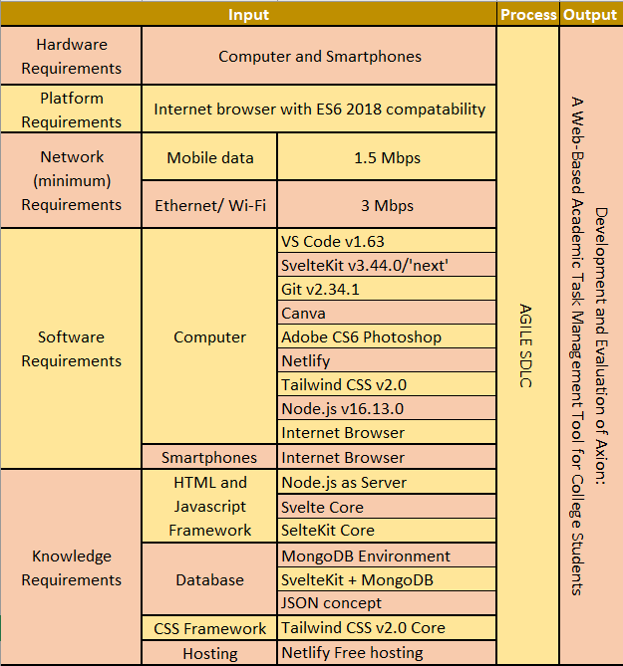

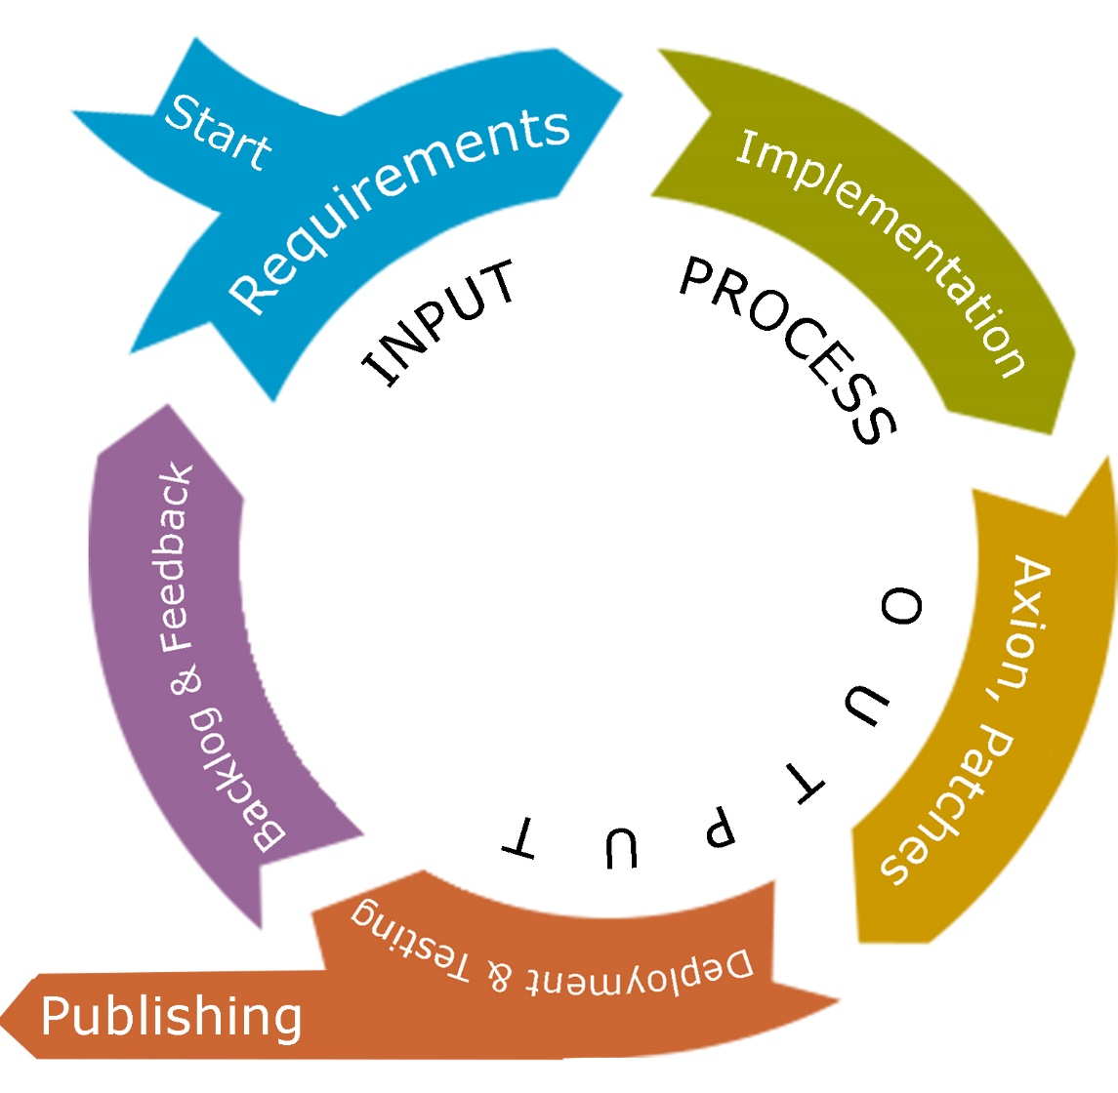

*Figure 1. IPO Model of development of Axion*

The researchers first look at the requirements to develop such system and this requirement are divided into five (5) categories. The categories are hardware, platform, network, software and knowledge requirement. Computer and smartphone for hardware requirement, as this is the most common and possible gadget that the students have. An Internet browser with the minimum of compatibility with ECMAScript 6 2018 to run properly all the codes and files needed for other services, software and frameworks and is the recommended web technology. Being online-dependent system requires stable internet connection for it to work and as for the mobile data the minimum would be 1.5 Mbps and if by Ethernet or Wi-Fi the minimum is 3 Mbps, also this is a mandatory requirement for the researchers as they use the internet to gather information, data and to download software, plugins, extensions, and modules that is needed in the development. In the development phase requires software and this software requirement are categorized into two parts, first computer software and second smartphone software requirement to develop Axion. On computer software starts with the coding environment, Visual Studio Code in regards to the most stable and latest version and inside of the code editor has any extensions and tools that can be used for better coding and development. SvelteKit specifically version 3.44.0 for this version is the stable version of SvelteKit in regards to Svelte as its core and Tailwind CSS version 2.0, these are frameworks that will be used are inline to layout and design of the system to make coding phase faster for it allows developers to code with less typing and with a huge variety of support in its community for better UI and designs in which saves a lot of time for the developers of the system. Git for updating and distributing files of the system especially codes, in help of GitHub as the remote stream of the developer’s codebase. Canva for system layout and low fidelity prototyping. Canva also supports live collaboration. Adobe Photoshop CS6 for additional graphics for the system. Computer and smartphone internet browser is where the output will be displayed after development of the system, note that internet browser must be ES6 2018 compatible. For the researchers to be able to use the software properly especially the frameworks and about database they need the knowledge about Svelte, SvelteKit, Tailwind CSS and Node.js for this are the major languages or scripts they will use in the development. Followed by the database connection with MongoDB through SvelteKit. Publishing the Axion to make it in the internet live and can be accessed by anyone is done by free hosting of Netlify with its free subdomain name to access the web application.

On the process, researchers use the agile software development life cycle for this development is a rapid, fast, and has always changing the system being developed. Axion is not a long term project, after the publication of the system developers will no longer update it. At start of the development researchers gather all the requirements and finalize it and proceeds to the implementation in where the issues and bugs to the systems are in fix state and new features is to be develop and then next is to deploy it. If the system is not yet ready for publication the output is the Axion a web-based academic task management tool for college students, else additional patches and features or fixed bugs and errors in the system are released as patches or in version type.